St. John Paul II
Child Care Center
Handbook
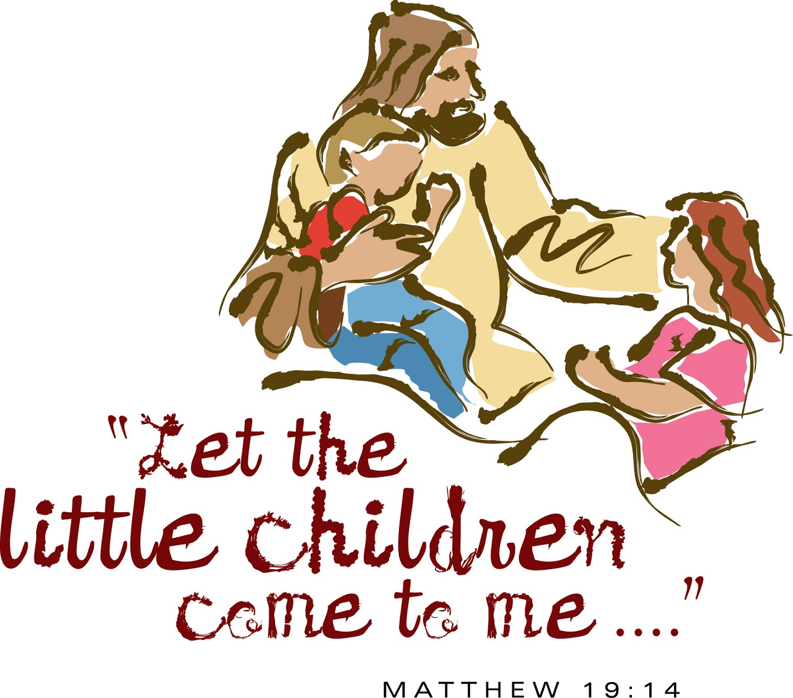
2023-24
Dear Parents,
We would like to welcome you and your child to the St. John Paul II Child Care Center. We look forward to having your child with us and feel confident that he or she will have a very enjoyable and beneficial experience here.
Each child will be given the opportunity to develop physically, socially, emotionally, mentally, and spiritually by being exposed to math, the basics of reading, art, music, stories, group activities, creative play, and religion classes.
You can help your child gain even more from new experiences by showing an interest in daily activities. You are encouraged to visit occasionally if possible.
If your child has spent few days away from home, there may be tears. Feel free to visit our childcare center ahead of time to better prepare him or her for the experience. Once a new child becomes accustomed to the routine and makes new friends, you can expect to see smiles and an eagerness to return on following days.
This handbook is provided to give you information and instructions concerning your responsibility as a parent. We hope it will help us work together in giving your child a positive experience.
Please feel free to talk with us anytime you have questions or comments concerning our program. We appreciate your input.
God Bless,
Robin Cahoy, Director

LICENSED
The St. John Paul II Child Care Center is fully licensed by the state of South Dakota.

ENROLLMENT
Children aged 3 – 5 are accepted on the basis of need without regard to religion, race, color, creed or sex. Therefore, once a student begins kindergarten, he or she will not be able to attend the St. John Paul II Child Care Center. We will also have an After School Care group of students ranging in age from kindergarten to 6th grade students.

DAYS AND HOURS OF OPERATION
The St. John Paul II Child Care Center follows the John Paul II school calendar. In mid-August through May we are open from 7:30 AM to 3:15 PM on the days that the school is in session.

SNOW DAYS
If school is cancelled because of snow or inclement weather, it will be announced over KORN, Q107, KELOLAND Closeline, and KMIT radio stations by 7:30 AM. This determination will be made by the Mitchell Public Schools due to joint busing. If school is dismissed early due to inclement weather, students will be dismissed according to the Emergency Dismissal Forms which are sign by each family at registration. A Remind message will also be sent to the connected parents.

STAFF QUALIFICATIONS
*The Director and Teachers must have a Bachelor’s Degree in Elementary or Early Childhood Education plus two years of experience or an Associate Degree in Early Childhood Education and experience in working with the young children. This group plans and submits program lessons.
*Teacher Assistants or Child Care Workers must be 18 years old, high school degree/or college degree, and have at least one successful year of experience working with children. The Director or teacher supervises teacher assistants.
*Secondary Child Care Workers must be 14 years of age and must work under direct and constant supervision of an adult.
*Volunteers used to fill staff member positions will have to meet the requirements for the position.
*No Staff member or volunteer will have a substantiated report of child abuse or neglect, or a felony conviction on record within the past five years, a sex offense, a crime of violence, or a crime against children.
*Staff member cannot be on the sex offender registry.

All staff are required to read and sign a child abuse/neglect form.

You will find that our staff more than meets these qualifications and has a very caring and concerned attitude and rapport toward children and their needs.

The Center maintains a ratio of one adult to 10 children in the Child Care Center and After School Care for children ages 3-4. A ratio of one adult to 15 children is maintained for children ages K – 6th grade.

TYPICAL DAYCARE SCHEDULE:

Child Care Daily Schedule
Morning Child Care Schedule:

7;30-8:00 Multi Purpose Room
8:00-8:30 Arrival, free choice time, take daily attendance
8:30-9:00 Circle Time, Daily Prayers, Weather/Calendar
9:00 – 9:15 Music and Storytime
9:15 – 9:30 Bathroom/Snack time
9:30 – 9:45 Outdoor/Large Group
9:45 – 10:45 Religion/Art/Math
10:45 – 11:00 Clean-Up
11:00 – 11:15 Bathroom/Wash Hands
11:15- 11:45 Lunch Time

Afternoon Child Care Schedule:

11:45 – 12:00 Bathroom/Wash Hands
12:00 – 12:15 Storytime
12:15 – 1:15 Rest time
1:15 – 1:30 Free play/Bathroom/Wash hands
1:30 – 1:45 Snack Time
1:45 – 2:15 Math/Art
2:15 – 2:30 Outside/Large Group
2:30 – 2:45 Religion
2:45 – 3:15 Story Time/Music/Backpacks/Dismissal

TYPICAL AFTER SCHOOL CARE SCHEDULE:
The After School Child Care begins at 3:15 and closes at 5:45 p.m. each weekday.

Depending on the number of children in attendance the children will be divided into smaller more manageable groups. There will be a teacher with the students at all times. The time in After School Child Care will be divided into: snack time, play time, quiet time, work time, and outdoor time depending on weather conditions.

Other than the Child Care Center room, students can be with their teachers in the outdoor space and also in the multi-purpose room or the school gym.

The children will need to be checked out of the Center by their parents or a legal guardian, or a person that has been appointed to pick them up by a parent or legal guardian.

DAYCARE ACTIVITIES:
Curriculum, using a weekly theme, includes: sharing and conversation time, stories, songs and puppets, creative art activities and crafts, exposure to shapes, colors, numbers, letters, and religion lessons. Lesson plans are written by the teacher.

PARENT-TEACHER CONFERENCES:
If you feel a conference is needed at any time you may schedule it with the teacher. We will not discuss the child in his or her presence. Typically, conferences are scheduled with the child’s preschool portion of the program in the fall and spring.

ADMISSION:
- Your child must be 3 years old by September 1st and toilet trained as of admission date.
- Before coming to the Center, you must submit a written statement signed by a licensed physician, physician’s assistant or a Dept. of Health representative showing immunization status of your child. All immunizations must be up to date. You must bring an updated immunization form into the school office whenever new immunizations are received.
- You will need to complete and sign a Registration Form which gives us information about your child, and emergency contact information. It is important that the information on this form is accurate and updated so that the school can contact the parent/guardian in the event of an emergency.
- Any changes in address or phone number should be reported to the teacher and Director.
- A non-refundable fee of $150 is paid for the Preschool portion of tuition.

PARENT’S RESPONSIBILITIES:
- Call St. John Paul II School (996-2365) by 8:00 AM if your child will not be in attendance of a scheduled day.
- Drop-off and pick-up your child at the regular prearranged time unless you specifically inform the Center of a change in schedule.
- If someone other than you will be picking up your child on a specific day, notify the Center or St. John Paul II School in advance. We will not release your child to someone we do not know and is not on your list!
- Your child will enjoy his play more if he is dressed in comfortable, easy to launder clothes. He also needs to have extra clothing in his school bag in case of an accident. It is very important that your child’s clothing be very suited for the season and weather condition of the day. Shoes must be worn at all times.
- Check weekly newsletters and classroom bulletin boards for any information on your child’s classroom activities.
- Please bring a SMALL labeled blanket for rest time. If you would like to bring a pillow, make sure it is a SMALL one. Dolls and stuffed animals are NOT NEEDED.
Blankets will be put back into your child’s school bag before the end of the day. That way they can be used and laundered at home.
- Please refrain from letting your child bring toys, etc. from home. These items cannot be shared by all and have a tendency to disappear or become destroyed. The parent may be asked to take the item home, or it will be taken away from the child until the parents pick up the child at the end of the day. Under whatever circumstances, the Center will not be responsible for the item(s).

CHILD ABUSE:
The Center has a legal obligation to report any suspected or observed incident of child abuse or neglect to law enforcement officials or to the Department of Social Services within 24 hours of the incident. Upon learning of an incident the Director will handle this immediately. All Staff are required to read and sign a child abuse and neglect obligation form.
- Any staff member who has knowledge of or has a reason to suspect child abuse or neglect shall report this immediately to the site supervisor/director.
- Site supervisor/director shall immediately report information to the Department of Social Services, the office of State’s Attorney or the police department.
- Due to the urgency of the situation, it may be necessary to notify the Department of Social Services, police department, or State’s Attorney before site supervisor/director.
- Contact with the parents/guardians regarding the report will originate with the Department of Social Services, police department, or State’s Attorney’s office.
- Documentation is important. The staff member should document observations in writing to include the date of the incident, time, those involved and a description of what was observed.
- In the event of a staff member being accused of child abuse or neglect, the employee will be suspended without pay until charges are investigated. The continued employment of the staff member will be evaluated based on the outcome of the investigations.

Shaken baby syndrome is caused by the brain moving back and forth inside the skull and being bumped, bruised or twisted. John Paul II Child Care Center requires any care provider, employee, or substitute who provides care and supervision to children under age 5, to be trained in recognizing what shaken baby syndrome is, how it is caused, what the symptoms of the syndrome are, and how to prevent shaken baby.

TUITION AND FEES:
- A non-refundable registration fee of $150 is required for your child’s enrollment. It is due with registration forms. This amount will be applied to the first month of tuition.
- Tuition will be charged by the month.
- Our monthly charge is based on the child’s enrollment.
Morning Preschool only
Afternoon Preschool only
Preschool plus daycare
After School Child Care
Payment is due each month according to the dates set up on TADS by the families.
- If tuition payments are not kept up to date your child may be dropped from enrollment until the account is paid in full for the month.
- There will be a charge on all returned checks.
- If services are no longer needed, the parent/guardian must notify the St. John Paul II Child Care Center within two weeks of the care termination. There will be no refunds for the current month already paid.

NUTRITION:
- The St. John Paul II School will prepare and serve the lunches to the children in the Child Care Center Program. Lunch will be served at 11:15 in the school gym with the kindergarten and first grade students. All meals are well balanced and served in accordance with standards set forth by the Child and Adult Nutrition Services of South Dakota.
- Menus are sent home monthly with the school newsletter.
- There will be mid-morning and mid-afternoon snacks served in the Child Care room.
- Make sure the teacher, director, head cook, and assistant cook are aware of any allergies. Cold items will be refrigerated. We will need a written note from a doctor stating any allergies.
- We discourage children from bringing food from home, unless it is a snack (in the original package) that all children in their class can enjoy.
- We are a peanut conscious school. Snacks brought from home cannot be made in a peanut factory or with any type of peanut oil or peanut butter.
St. John Paul II Child Care Center requires staff to be trained in the area of food and allergic reactions. St. John Paul II Child Care Center requires all parents to complete an enrollment application and if there are allergies, to list those allergies. When a parent lists any allergy, they are required to complete a document that lists the allergy, what the allergy is related to (food, pets, etc.); what the signs and symptoms of distress are should the child have an allergic reaction; and what the process is for assisting the child should they be in distress due to a reaction. Each staff person who is associated with this child (teacher, cook, etc.) is provided an overview of the situation, an overview of the allergy document and the instructions for preventing a reaction, and instructions for handling a reaction.
DISCIPLINE:
- Acceptable behavior is encouraged by giving positive verbal reward. This reinforces a child’s good feeling about his or her behavior and serves as an example to the other children to act in such a way as to receive the praise also. Asking a child to stop and think about his or her unpleasant behavior enables that child to work at self-control.
- For a child not cooperating in a group listening situation, the child is seated by a teacher and reminded of acceptable behavior.
- Removal from the group for a period of time-out is the next step used for a child who continually demonstrates unacceptable behavior. This time-out is not a punishment, but rather a time when the child may calm down, remember what behavior the teacher is asking for, and decide for himself or herself when he or she is ready to rejoin the group with appropriate behavior.
- Corporal punishment is not considered to be an accepted method of dealing with a child’s behavior. The use of humiliating and frightening punishments is prohibited. Children will not be hit, slapped, pinched, shaken or spanked in any manner while attending the St. John Paul II Child Care Center.
- Peers in the Child Care Center are prohibited from administering discipline.
- St. John Paul II Child Care Center reserves the right to dismiss any child that does not exhibit appropriate behavior, which would include safety of other children, and does not conform to the daily routine of the Center. The parent will be informed of the concerns with a conference, and if behavior does not improve a two week notice will be issued.

HEALTH:
1. Medical Records
The Diocese of Sioux Falls has mandated that all children entering preschool/daycare or new students present documented proof that the following immunizations have been received:
- DPT (diphtheria, pertussis, and tetanus), 4 doses Toxoid - one after age 4
- Poliovirus, 3 doses – one after age 4 or 4 total
- Measles, 2 doses of vaccine
- Rubella, 2 doses of vaccine
- Mumps, 2 doses of vaccine
- Chicken pox (varicella), two doses of vaccine or history of disease
- Hepatitis B vaccine
- Hepatitis A vaccine
- Pneumococcal vaccine
- All other doses required by the State of South Dakota
- It is the responsibility of the parent to keep immunization records current. These current records will be given to the staff member/director to be contained in the child’s record folders.

Recommended but not required:
- HPV vaccine

2. Accident/illness at school
Accidents or unusual illnesses occurring at school are reported immediately to the principal or main office personnel. When a student becomes ill or meets with an accident, the parent or guardian is contacted and the child is sent to St.John Paul II School office until the parents can come and take the child home. If the parent or guardian cannot be reached, the emergency contact will be called. No medicine of any kind, including aspirin, may be given to the student. Only basic first aid may be administered. Parents must be contacted immediately if there is any question regarding an injury. The teacher who was supervising the student at the time of the accident will fill out an accident report before the end of the day.
3. Medications
Parents are encouraged to give medications at home whenever possible.
Prescription medications to be administered by school personnel must be provided in a labeled container from the pharmacy or physician with the student’s name, date, medication name, dosage, and frequency to be given. The school will keep a log of all administered prescription medication. This log will include the day, time, and initials of 2 office/staff personnel who were present when prescription medications were administered.
A note signed by a parent/guardian must accompany the medication. The note must specify what dose the school personnel is responsible for administering. If the school does not have written permission, the dose must be given by the parent/guardian.
If an increase or decrease in medication dosage is required, the doctor’s office must fax the requested changes. St. John Paul II’s fax number is 995-0378.
NON-PRESCRIPTION MEDICATION SUCH AS ACETAMINIPHEN OR WETTING DROPS WILL NOT BE PROVIDED BY THE SCHOOL.
If your child needs a non-prescription medication, he/she may bring this medication to the office in the morning in the original, labeled container with a note from the parent as to the dosage to be given. This medication will be marked with the student’s name and kept in the school office. The school will keep a log of all administered medication.
If a student needs to carry an inhaler(s), the parent must send a note that indicates the approval for self-administration. Parents need to properly label the inhaler. The school will not keep a log for this medication.

Head Lice
Head lice has nothing to do with cleanliness; in fact, head lice prefer a clean, healthy head to a dirty one. Anyone, adult or child, can get head lice. The most common symptom of infestation is intense itching on the back of the head or neck. Head lice cannot survive without a human host or on family pets. There is little evidence to support that they carry disease.
Head lice are passed from person to person by direct contact or on shared objects such as hats, combs, towels, barrettes, headphones, etc. So, you may want to encourage your child to keep these things to him or herself. If you do find head lice, don’t panic -- just follow the steps below to easily take care of the problem.
- Check every member of the family. Lice are hard to spot, so look for tiny white eggs (nits) on hair shafts near the scalp, especially at the nape of the neck and behind the ears.
Head lice are small, wingless, grayish-tan insects. Any family member with lice or nits must be treated.
- Use an effective head lice treatment. Several are available without a prescription. NIX Creme Rinse is the only product that is proven 99% effective with just one application in killing lice and eggs and protecting from re-infestations for two weeks.
3. Remove all nits. Gently comb the child’s hair with the special nit removal comb. The combs are provided with most lice treatment products. NIX is a creme rinse formulation that makes combing easy. Students need to be nit-free before they can be readmitted.
4. Wash clothes, bed linens, and towels: use hot water and then dry on the hot cycle for at least 20 minutes. Items such as stuffed animals, headphones, and hats that are not machine washable must be dry-cleaned or stored at room temperature in a tightly-sealed plastic bag for at least two weeks.
5. Soak combs, brushes, etc., in hot water. The hotter the better, but the temperature should be at least 130 degrees F. Items should soak for at least 10 minutes.
6. Vacuum everywhere. To make sure the rest of your home is louse-free, you should vacuum carpets, pillows, mattresses, upholstered furniture, and even the car seats.

Communicable Diseases Reference – Students

RECOMMENDATIONS
for Temporary Exclusion from a
CHILD CARE SETTING

 Illness that prevents the child from participating comfortably in program activities.
 Illness that results in a greater need for care than the staff can provide without compromising the health and safety of other children.
 Fever, lethargy, irritability, persistent crying, difficult breathing and/or other manifestations of possible severe illness.
 Persistent abdominal pain (continuous for more than two hours) or intermittent abdominal pain associated with fever, dehydration, or other systemic signs or symptoms.
 Chicken pox (Varicella): exclude until all lesions have dried and crusted or, in immunized children without crusts, until no new lesions appear within a 24-hour period.
 Diarrhea: exclude if

 stool not contained in diaper
 fecal accidents occur in a child normally continent
 stool frequency exceeds two or more stools above normal for that child
 stool contains blood or mucus

 E. coli, shiga toxin-producing (STEC): exclude until diarrhea resolves and two stool cultures are negative.
 Haemophilus influenzae type B, invasive (Hib): exclude until after 24 hours of antibiotic treatment.
 Head lice (Pediculosis): refer for treatment at end of program day and readmit on completion of first treatment.
 Hepatitis A: exclude until one week after onset of illness.
 Impetigo (Streptococcal infection of the skin): exclude until after 24 hours of antibiotic treatment.
 Influenza and Influenza-like illness: exclude as long as fever ≥100 degrees Fahrenheit is present in an unmedicated state. Additional exclusions may be necessary for documented novel strain or pandemic influenza based on state or federal guidance.
 Measles: exclude until 4 days after onset of rash.
 Meningococcal disease (Neisseria meningitidis): exclude until after 24 hours of antibiotic treatment.
 Methicillin-resistant Staphylococcus aureus (MRSA): generally no exclusion; considerations may exist if confirmed MRSA is present from a wound in which drainage is occurring and cannot be covered and contained.
 Mouth sores: exclude if associated with drooling, unless a physician has determined it is not a communicable disease.
 Mumps: exclude until 5 days after the onset of parotid gland swelling.
 Pertussis (Whooping cough): exclude until completion of 5 days of recommended course of antibiotic treatment. If appropriate antibiotic treatment is not received, exclude until 21 days after onset of symptoms.
 Rash (with fever or behavior change): exclude until a physician has determined it is not a communicable disease.
 Rubella: exclude until 7 days after onset of rash.
 Scabies: exclude until after treatment has been completed.
 Shigella: exclude until 24 or more hours after diarrhea resolves.
 Strep throat (Streptococcal pharyngitis): exclude until after 24 hours of antibiotic treatment.
 Tuberculosis: exclude until a physician, concurring with the SD Department of Health, states the child is not infectious.

 Vomiting: exclude if vomiting occurs unless the vomiting is determined to be caused by a non-communicable condition and the child is not in danger of dehydration.
- Coronavirus (COVID- 19): follow the direction given by your medical professional.

2015 Red Book, American Academy of Pediatrics, 30th Edition; 2013 Managing Infectious Diseases in Child Care and Schools, A Quick Reference Guide, American Academy of Pediatrics, 3rd Edition; 2015 Control of Communicable Diseases Manual, American Public Health Association, 20th Edition.

We will comply with the State of South Dakota Reportable Diseases requirements. The director will report all contagious diseases to the Department of Health.

TRANSPORTATION:
No field trips are scheduled for the Center. Any field trips will be taken through the preschool classroom.

EVACUATIONS:
Our program has developed an emergency preparedness and response plan to address emergency issues that may arise at the program. Staff review this plan upon hire and the plan is reviewed again on a yearly basis to make any changes and updates as needed.
Should it be necessary to evacuate for fire, the staff has been instructed in procedures for exiting the building. The Center (through St. John Paul II School) conducts a minimum of four fire drills per year and written evacuation plans are posted. In case of a severe storm, the children will be gathered in the hallways away from any windows. At least two tornado drills are conducted each year. Evacuation and Safety procedures are located by the classroom door.
1. Crisis Plan
Crisis plans for fire, tornado, bomb threat, and active shooter are posted in each room. The teachers instruct the students about what to do in the different situations.
2. Fire Drills
Fire drills are conducted on a regular basis. The students are instructed to leave the building quickly and in silence when the alarm rings according to directions posted in each area. Failure to cooperate is considered a serious matter.
3. Regulations
The following regulations have been established to ensure the safety of our students and must be adhered to by each student:
- Running is not permitted at any time within the school building or in moving from one place to another on the school premises.
- Entry is not permitted into the classrooms before school, at recess or lunch, or after dismissal at any time, unless a member of the school staff gives explicit permission to do so.
- No student may leave the school premises at any time without permission. Every student must stay within the established boundaries when outdoors for morning, afternoon and lunch recess.
- For the safety of our children, all doors will be locked at 8:30AM and reopened at 3:00PM. Entrance A (south door by the office) is the only door for entry during this time. All Visitors and Parents must sign in at the office. See School Visitor and Volunteer Policy.

4. Asbestos
We do have a small amount of asbestos in our school. The proper steps have been taken.

DISPOSAL OF BIO-CONTAMINANTS
St. John Paul II Child Care Center requires all staff to be trained in the area of Universal/Standard Precautions. Universal/Standard Precautions are guidelines issued to prevent disease transmission for people in all walks of life, including child care providers. The Universal/Standard Precautions require persons to have a barrier between any infectious substance and the workers skin, eyes, nose, and mouth. St. John Paul II Child Care Center requires any care provider, employee, or substitute who provides care and supervision to children to follow the universal/standard precautions recommended by the Centers for Disease Control and Prevention (CDC) in handling any fluid that might contain blood or other body fluids. Universal/Standard Precautions require treating all blood and fluids that may contain blood or blood products as potentially infectious.

CONFIDENTIALITY OF RECORDS:
Children’s records are open only to the child’s teachers, the Director, an authorized employee of the licensing agency, or the child’s parent or legal guardian. St. John Paul II School and Child Care Center maintains a high level of confidentiality regarding the children in these programs and we need to assure that details of a child’s life or those of a child’s family are not shared with unauthorized individuals.
In addition:
- All child record folders are considered the property of St. John Paul II School. All information in each child and staff record folder is confidential.
- Each supervisor/director shall assume the responsibility for possession and maintenance of each child and staff record folder.
- Staff who are directly involved with a child may have access to the child record folder.
- Information in the file shall not be released to anyone unless the request is approved in writing by the director.
- All financial records concerning a child enrolled is confidential.
- All information discussed in a staff conference/meeting is confidential.
- Any misuse or mishandling of confidential information to unauthorized individuals shall be brought to the attention of the director.

CHANGES OR CIRCUMSTANCES:

"The program is required to report changes or circumstances, within 24 hours, which may affect the ability to comply with licensing rules such as a new program location, building renovations or remodeling, suspected in-house child abuse or neglect, ownership change, employee felony convictions or a new director."

PLEASE KEEP THIS HANDBOOK IF NEEDED FOR FUTURE REFERENCE.

